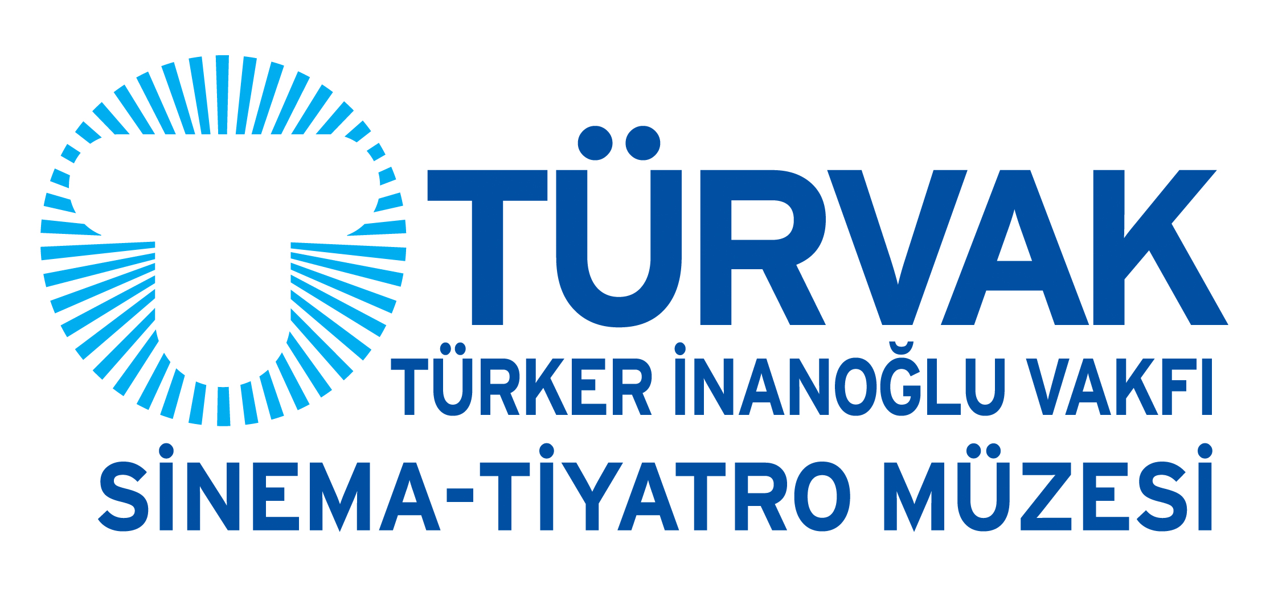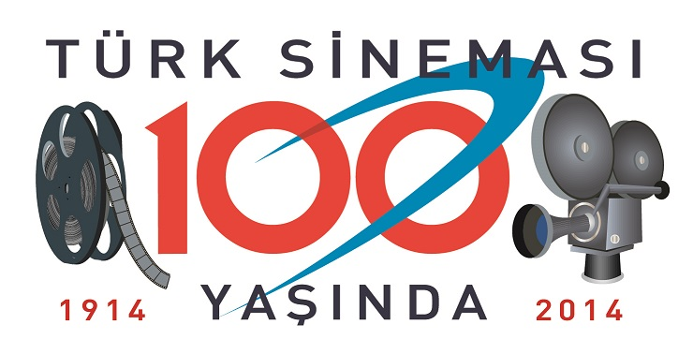

PRESS BULLETIN

51st ANTALYA GOLDEN ORANGE FILM FESTIVAL’S

“100 YEARS OF TURKISH CINEMA
THROUGH 100 ILLUSTRATIONS” EXHIBITION is in

TÜRVAK CINEMA-THEATRE MUSEUM!

12 February 2015 – 15 March 2015

TÜRVAK Cinema-Theatre Museum is hosting “100 Years of Turkish Cinema Through 100 Illustrations” exhibition between 12 February and 15 March 2015.

Exhibited for the first time within the framework of the 51st International Antalya Golden Orange Film Festival and curated by cinema, music and arts magazine Bant Mag., “100 Years of Turkish Cinema Through 100 Illustrations” exhibition is now meeting with the art lovers in Istanbul’s TÜRVAK - Türker İnanoğlu Foundation Cinema-Theatre Museum.

The exhibition presents a collection of art works by 20 young illustrators in reference to the list of 100 classical Turkish films including Vurun Kahpeye/Strike The Whore (1949), Yalnızlar Rıhtımı/The Lonely Ones’ Quay (1959), Sevmek Zamanı/Time To Love (1965), Sürü/The Herd (1978), Karılar Koğuşu/Women’s Ward (1989), Eşkıya/The Bandit (1996), Bal/Honey (2009) and Kış Uykusu/Winter Sleep (2014), which was determined according to the result of the survey conducted among academics and cinematographers in Turkey by the Ministry of Culture and Tourism. Produced with both contemporary and traditional techniques, the illustrations add an interdisciplinary dimension and a visual richness to the entire exhibition.

The name of the illustrators who interpreted portraits, film stills and posters with their very own artistic language are Gökhan Akbaba, Saydan Akşit, Aykut Aydoğdu, Ezgi Beyazıt, Ethem Onur Bilgiç, Furkan ‘Nuka’ Birgün, Vardal Caniş, Can Çetinkaya, Berkay Dağlar, Burak Dak, Sedat Girgin, Sadi Güran, Mark Hale, Murat Patla, Naz Tansel, Asuman Tanyaş, Duygu Topçu, Mert Tügen, Ada Tuncer and Mehmet Uluşahin.

“100 Years of Turkish Cinema Through 100 Illustrations” exhibition will be open to visit between 12 February - 15 March 2015 in TÜRVAK Museum Exhibition Hall from 10 am to 6 pm, everyday except Mondays.

EXHIBITION OPENING PROGRAM (INVITATION-ONLY)

Date: 12 February 2015 Thursday, 6 pm

Venue: TÜRVAK CINEMA-THEATRE MUSEUM
Yeniçarşı Caddesi No:24 Beyoğlu, İstanbul
+90 212 245 80 92 www.turvak.com info@turvak.com

Contact: Aslı Canan Yılmazsoy
aslicanan.yilmazsoy@turvak.com
+90 533 362 26 60

