GLOBAL Comscore – Sunday Estimates – Weekend Box Office Roundup – December 19, 2021

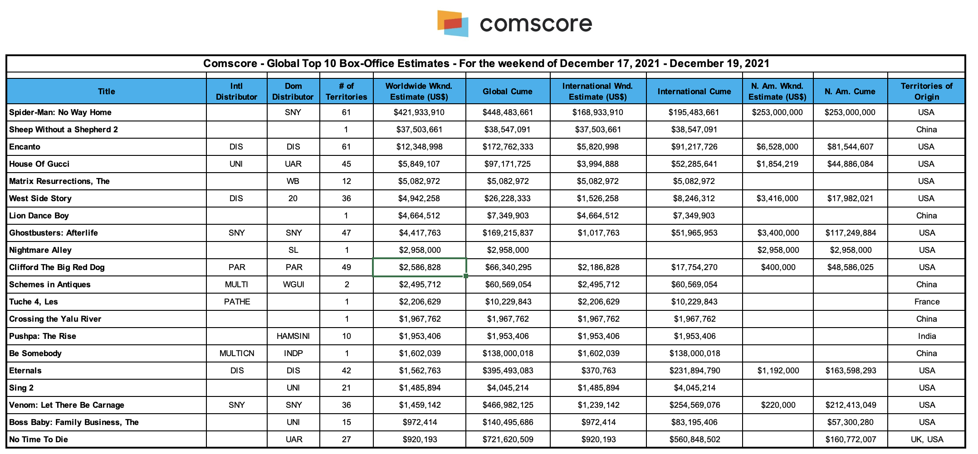
A re-cap of this weekend’s notable performers as reported by their respective distributors.

Notable International Openers:
Sony’s presentation of Columbia Pictures’ “Spider-Man: No Way Home” launches to the highest opening weekend in the 100+ years history of Columbia Pictures as it slings past the half a billion-dollar mark in just five days. The film dominated box office charts around the world with a stunning $334.2 million from 60 overseas markets in 38,900+ screens for a global total of $587.2 million, the third biggest opening ever.
Warner Bros.’ “The Matrix Resurrections” debuted in Russia, Japan, Thailand and 4 smaller markets this weekend bringing in an estimated $9.2m on 3,303 screens. In like for like markets and using today’s rates, the film is tracking +8% ahead of ETERNALS and +12% ahead of TENET. There are 69 overseas markets scheduled to release next week along with the U.S. and Canada.
Notable International Performers:
Disney’s presentation of “Encanto” earned $7.9M in 47 material territories and when combined with its North American weekend of $6.5M earned $14.4M globally this weekend and now has a global cume of $175.5M.
Paramount’s “Clifford The Big Red Dog” grossed $3.6M this weekend across 41 markets. The total international cume is $19.4M. These markets represent 81% of the international footprint.
20th Century Studios “West Side Story” this weekend in 47 material territories earned $2.1M and when combined with the N. Am. weekend of $3.4M earned $5.5M globally this weekend and now has a global cume to date of $27.1M.
Columbia Pictures’ “Venom: Let There Be Carnage” grossed $2.0M this weekend overseas from 2,500+ total screens in 57 markets for an international cume of $285.7M and a global total of $498.1M.
Columbia Pictures’ “Ghostbusters: Afterlife” added $1.8M from 4,000+ screens in 53 markets for an international cume of $56.4M. Upcoming major market release(s): Australia (1-Jan), Japan (4-Feb).
Universal’s “Sing 2” now in week 3 internationally took in $1.425M in 16 territories for a international cume of $4.830M to date.
Warner Bros.’ “Dune” took in an estimated $1.1m this weekend, bringing the international cume to date to $286.3m and the worldwide tally is $393.2m.
Disney’s presentation of Marvel’s “Eternals” earned $700,000 in 43 material territories and when combined with its North American weekend of $1.2M earned $1.9M for an international cume to date of $236.1M and a global cume to date of $399.7M.
International Spotlight on House of Gucci:
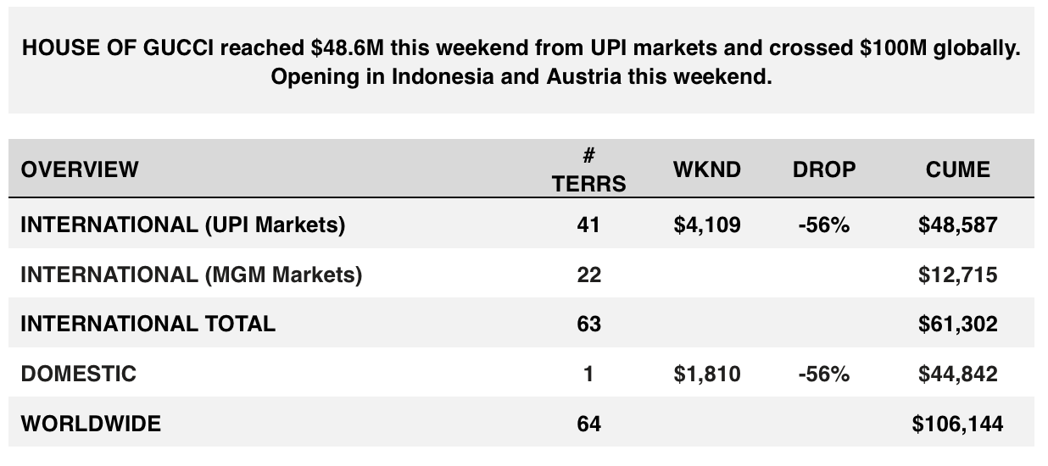
Chart courtesy of Universal:

International Spotlight on Bond:
Chart courtesy of Universal:
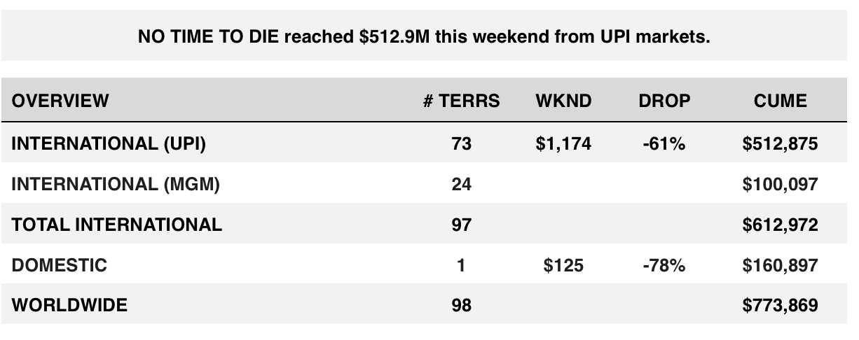
IMAX Highlights (courtesy of IMAX):
An historic weekend for Sony Pictures, as SPIDER-MAN: NO WAY HOME breaks numerous IMAX records on its way to $36.2m in global IMAX box office.
Proving that moviegoing is alive and thriving, NO WAY HOME captures the Biggest Global IMAX box office weekend ever for Sony Pictures, 25% higher than previous recordholder, SPIDER-MAN: FAR FROM HOME (which included China in its opening weekend markets). It’s also the Biggest Global IMAX Opening weekend since April 2019, the 3rd highest IMAX Global box office weekend in December and the 6th highest Global IMAX box office weekend ever.
North America delivers $22m of the global IMAX weekend total, the Biggest Domestic IMAX box office weekend ever for Sony, 47% higher than prior recordholder, FAR FROM HOME. NO WAY HOME is also the 3th highest IMAX Domestic box office weekend in December and 5th highest Domestic IMAX box office weekend ever. 407 IMAX Domestic screens yield an eye-popping weekend per screen average of $54K, with select locations playing the movie around the clock to meet demand.
The $14.2m rest-of-world total is also Sony’s Biggest International IMAX weekend ever, with 15 markets posting the Biggest IMAX opening weekend ever, including Mexico, India, Italy, Turkey and Saudi Arabia. Brazil and Hong Kong are among the 7 markets with the 2nd highest IMAX opening weekend ever.

In Asia, Spidey snagged $74.0M for the region, led by South Korea with $23.7M. India recorded an exceptional $18.2M, which is the #2 opening weekend in the market for a Hollywood film. Hong Kong grossed $6.3M, their 4th biggest opening of all-time. Other notable market totals: Indonesia ($8.2M #5 all-time opening), Taiwan ($7.3M), Malaysia ($5.1M).

