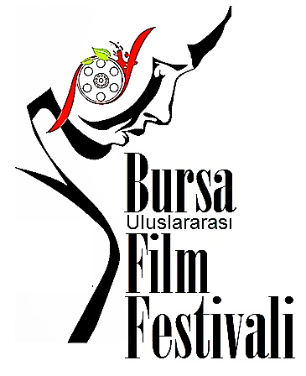

..............................................................................................................................................................................................................................................................................................................................................................................
www.uluslararasibursafilmfestivali.com
..............................................................................................................................................................................................................................................................................................................................................................................

BASIN BÜLTENİ
30.Mayıs.2020.Cumartesi
..............................................................................................................................................................................................................................................................................................................................................................................

HAFTALIK PROGRAM
1-7.HAZİRAN.2020

1 HAZİRAN.PAZARTESİ
SAAT:17.00 /
DAVİD LYNCH
BUSHNELL KEELER İLE YELKEN

SAAT:19.30 /
PEDRO ALMADOVAR
SALOME

SAAT:21.00 /
LARS VON TRİER
GECE

2 HAZİRAN.SALI
SAAT:17.00 /
TRUFFAUT / GODARD
BİR SU HİKAYESİ

SAAT:19.30 /
GEORGE LUCAS
ELECTRONİC LABYRİNTH THX 1138 4EB

SAAT:21.00 /
OLİVER STONE
VİETNAM’DA GEÇEN YIL

3 HAZİRAN.ÇARŞAMBA
SAAT:17.00 /
ROBERT RODRİGUEZ
YATAK BAŞI

SAAT:19.30 /
MARTİN SCORSESE
THE BİG SHAVE

SAAT:21.00 /
CHRİSTOPHER NOLAN
DOODLEBUG

4 HAZİRAN.PERŞEMBE
SAAT:17.00 /
JAN SVANKMAJER
DİYALOG BOYUTLARI

SAAT:19.30 /
TİM BURTON
VİNCENT

SAAT:21.00 /
WES ANDERSON
BOOTLE ROCKET

5 HAZİRAN.CUMA
SAAT:17.00 /
ANDREİ TARKOVSKY
KATİLLER

SAAT:19.30 /
ROMAN POLANSKİ
WE DESTROY THİS PARTY

SAAT:21.00 /
JEAN PİERRE JEUNET
FOUTAİSES

6 HAZİRAN.CUMARTESİ
SAAT:17.00 /
LUİS BUNUEL
ÇÖLÜN SİMON’U

SAAT:19.30 /
JEAN COCTEAU
BİR ŞAİRİN KANI

SAAT:21.00 /
ZBİGNİEW RYBCZYNSKİ
TANGO

7 HAZİRAN.PAZAR
SAAT:17.00 /
CHRİS MARKER
LA JETÈE

SAAT:19.30 /
LUİS BUNUEL
ENDULÜS KÖPEĞİ

SAAT:21.00 /
YURİ NORNSTEİN
MASALLARIN MASALI

Film gösterilerimiz, festivalimizin internet sitesi
https://www.uluslararasibursafilmfestivali.com/
da ‘ücretsiz’ olarak izlenebilir!...

