**Akademik Program**[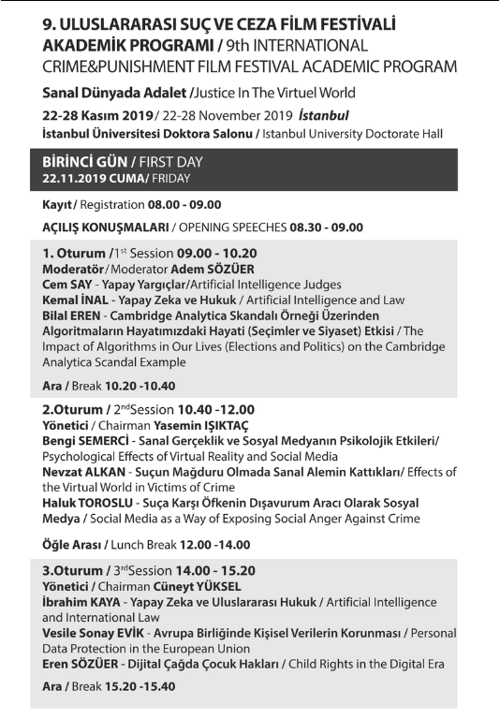](http://www.icapff.com/wp-content/uploads/2019/11/1.png) [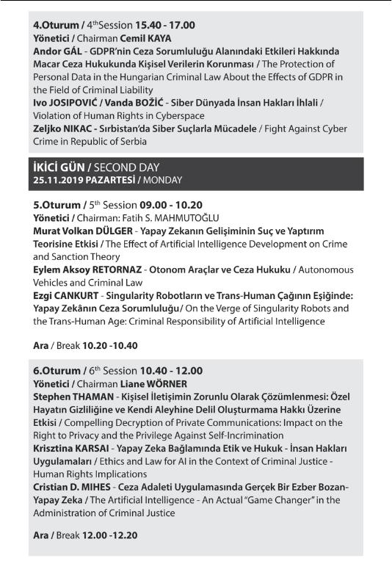](http://www.icapff.com/wp-content/uploads/2019/11/2.png) [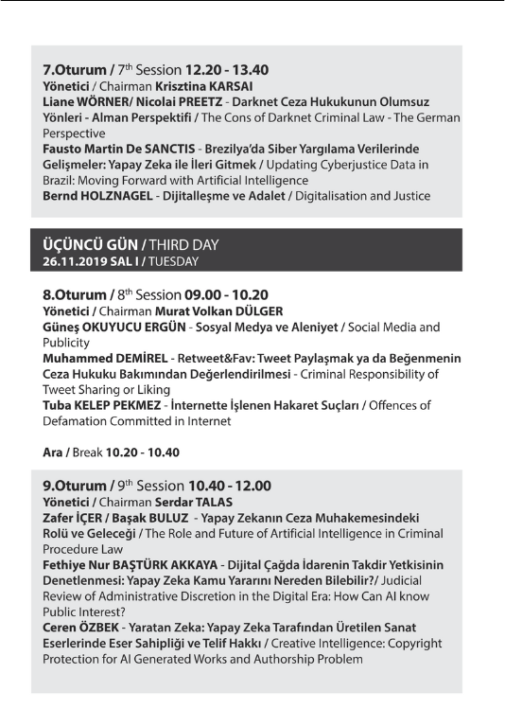](http://www.icapff.com/wp-content/uploads/2019/11/3.png) [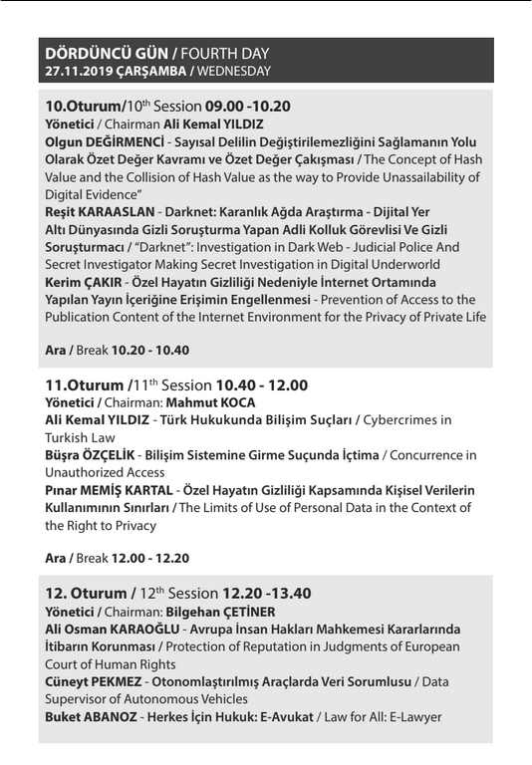](http://www.icapff.com/wp-content/uploads/2019/11/4.png)