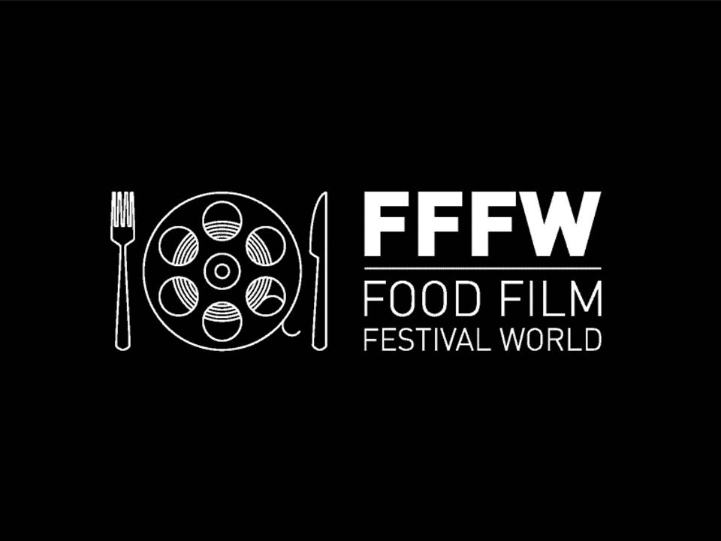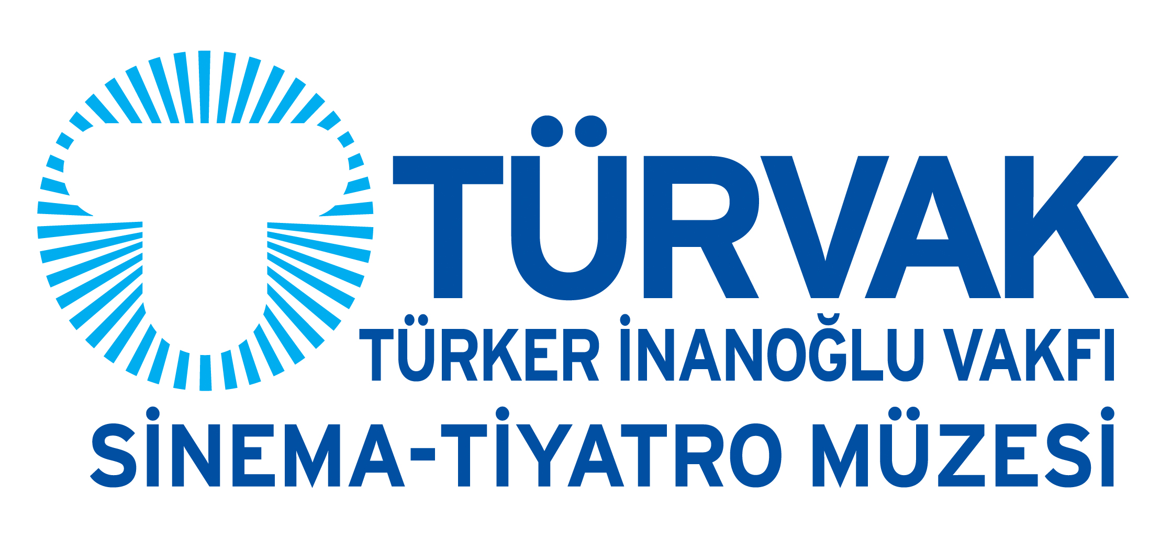

PRESS RELEASE

“FOOD FILM FESTIVAL WORLD” IN ISTANBUL!

The Most Delicious Movies Meet the Audience on 10 October.

Kiev based young team’s short food films festival project, the “Food Film Festival world” is taking place in Istanbul, on the 10th October 2015 in TURVAK Cinema Museum, after meeting with cinema lovers in different countries and cities.

Food… is more than just hunger. It is culture, philosophy, and art. Therefore the Food Film Festival presents the most profound productions related to gastronomy, social and cultural issues under the categories of Food & People, Cook Book, Tastes like Animal, and Food Ad.

Visitors of Food Film Festival world: Turkey will watch 19 movies from more than 10 countries, including one work of a Turkish movie director. The films are not like “How to cook some meal at home step by step”, not at all. They present and project to the screen the stories of success, comedies, love stories, and the preference of people from different cultures, that you can see just one common thing – the Food.

Food Film Festival world: Turkey, offers its audience not only the chance to watch tasty movies on the silver screen but to taste different and meticulously prepared meals.

During the festival, the participants will be able to attend Master Classes about coffee culture, bakery, tea and organic food and to listen to the experts in food sector (including academics, bloggers and project owners).

The Festival will take place on the 10th October 2015 in TURVAK Cinema Museum in Beyoğlu, from 1:00 pm to 10:00 pm. Details about the movies are available at http://tr.foodfilmfest.com.ua

Contact:
Oksana Roman | FFFw:Turkey Project Manager
oksana@foodfilmfest.com.ua
+90 541 900 91 36

